The Current Water Crisis
Current water policy is unsustainable and current water infrastructure is in poor condition
After years of prolonged and oscillating periods of drought, California is mostly but not completely out of drought. It is also now experiencing extreme flooding. The emergence from drought is also subject to change.
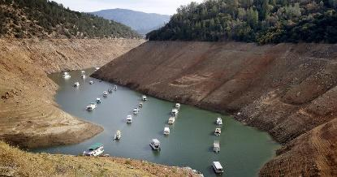
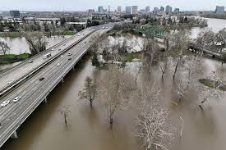
Last Year This Year

Extreme weather phenomena are also exacerbated by climate change and groundwater levels are critically low.
US Drought Monitor
California
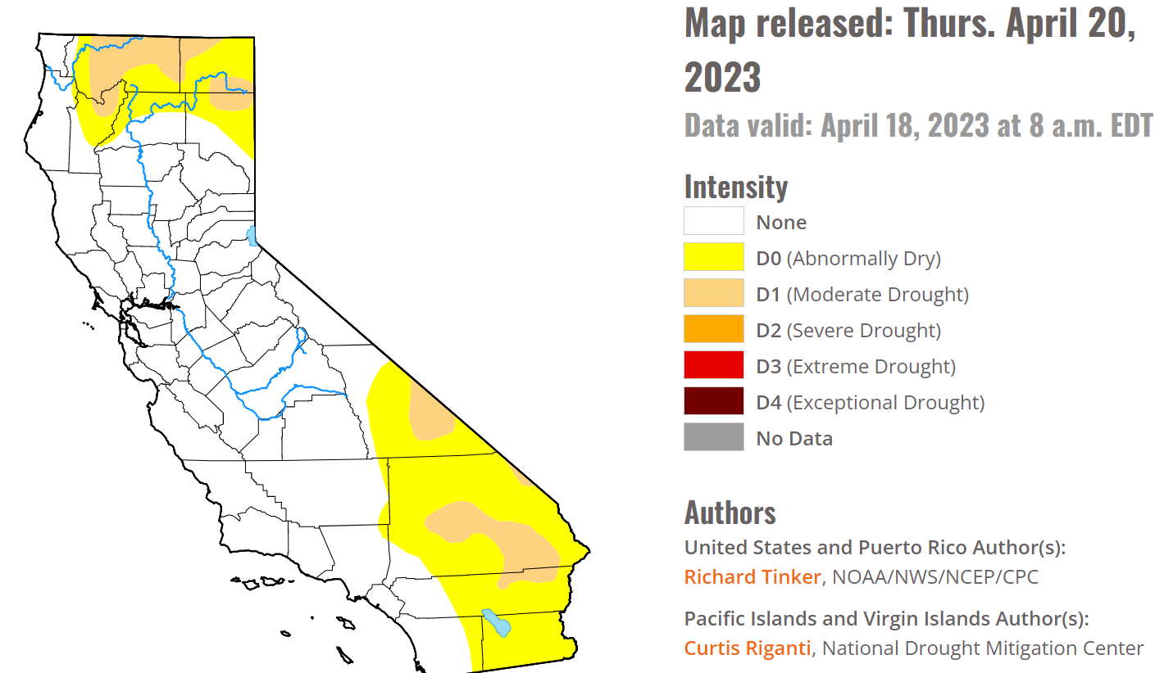
Old Solutions
Some regions and communities continue to call for the expansion of traditional water infrastructure-including dams, reservoirs, artificial channels, etc.
- Problem: This infrastructure requires the presence of water which is scarce and are expensive.
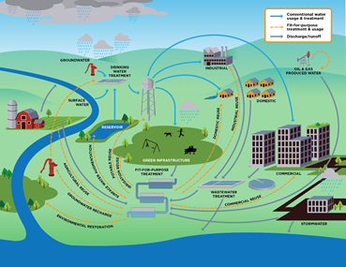
Alternative Solutions
Instead, the expansion of sustainable water infrastructure, energy, agriculture and nature-based solutions are needed. The Climate Reality Project: Los Angeles endorse the following:
Expanded water recycling-the reclamation and treatment of used water from multiple sources, then reusing it for other purposes.
- Proof of effect: Orange County has the nation’s largest water recycling plant which has permitted the adjacent aquifer to stay at 80% capacity despite ongoing drought conditions whereas most in CA are below 40%.
Rainwater capture-the collection of all rainfall. A majority of stormwater runoff is not captured as it enters the nearest waterway (unfiltered) often and eventually the ocean.
- Proof of effect: 30-50% of Los Angeles’ annual water needs could be supplied by natural rainfall, but currently go uncaptured.
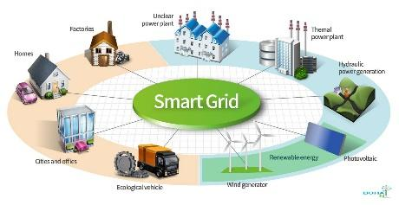
Renewable energy-Traditional carbon-based/fossil fuel derived energy generally requires water for cooling purposes whereas renewable energy does not.
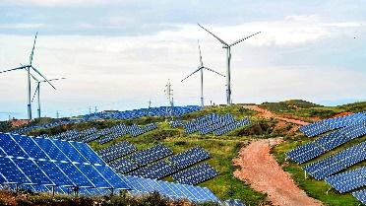
  - Increase Efficiency of Power Grid/Transition to a Smart Power Grid-A more efficient power grid, utilizes less energy and therefore, less water.
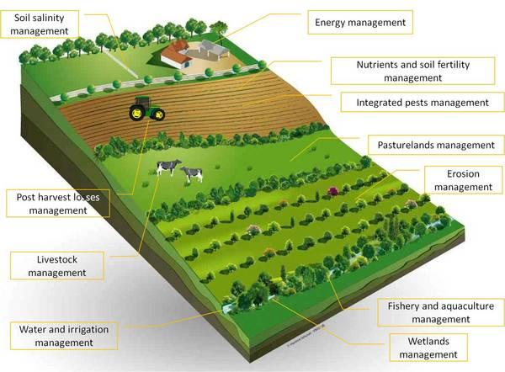
Sustainable Agriculture-Traditional, industrial agriculture utilizes 40% of water in California. Thus, the transition to growing drought-tolerant crops or developing less water-intensive agricultural methods.
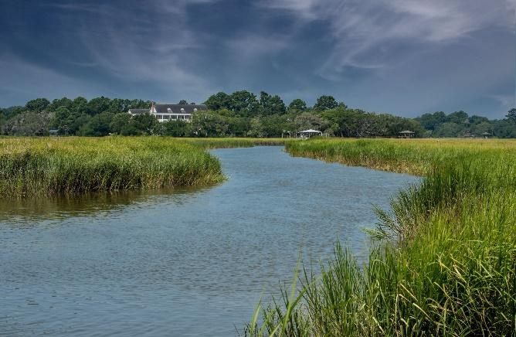

Nature-based Solutions-The incorporation of natural designs and processes into the built environment and infrastructure. For example: bodies of water without concrete and the development of floodplains.
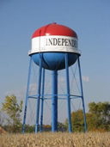
Additional Measures:
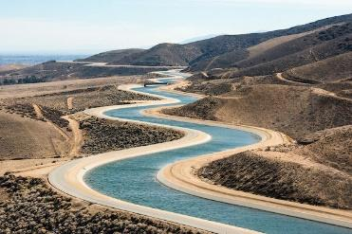
The establishment of local and state water independence goals with milestones
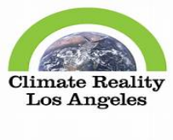
Cross-state/regional projects to increase water security
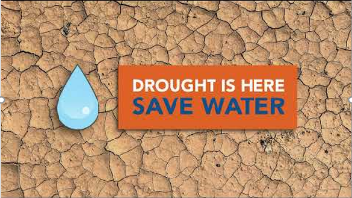
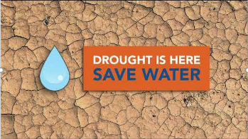
What Can I Do to Conserve Water
and Mitigate Drought?

Individuals should continue to focus on reducing their overall water consumption and waste. Individuals can take the following actions:
Conduct a water audit to determine sources of water waste, primary sources of water usage and ways to reduce water usage.

Use less water during everyday activities-showers, brushing teeth, washing dishes, etc.
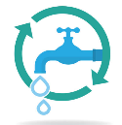
Install and/or use water-efficient equipment-dishwashers, toilets, showers, faucets, etc.

Install home-based water recycling systems (i.e. greywater systems)
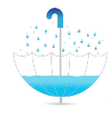

Install a rainwater capture system such as rain harvesting tank or cistern
Incorporate more plant-based dishes into meal plan/diet.
  - Go further by adopting a water-conscious diet-opting for dishes that require less water-intensive ingredients. In general, plant-based, dairy free and nut-free dishes require less water as livestock, dairy and nuts require higher quantities of water to grow.
Install drought tolerant landscaping, including native plants. Install smart irrigation systems or water efficient irrigation like drip irrigation.
  - Go further by installing landscaping elements and features that facilitate rainwater capture and groundwater retention such as permeable pavement, bioswales and underground cisterns.
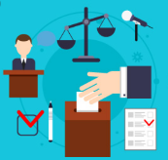
Reach out to local, state and national officials and advocate for the expansion of and investment in sustainable water infrastructure-water recycling and rainwater capture, renewable energy and sustainable agriculture and nature-based waterways and systems. These systemic changes/upgrades would lead to large scale reductions in water consumption.

Conserve, capture and re-use every drop for the future.

